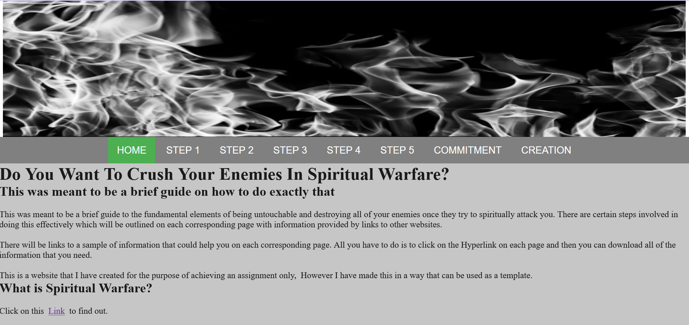

Title: Crush Your Enemies

ITWD5.130 – Practical Assessment Part 2

Website Review and Evaluation

Version 1.0

Prepared by: **Greg Wilkins** (2006001985)

# Table of Contents

Table of Contents 2

**Change review** 3

1. Changes made 3

I kept the site design the same 3

Navigation Bar Below 3

Video embedding instead of essays. 4

4

Video embedding instead of essays 4

2. Changes proposed (that you could have done differently or could add to improve your website) 5

Creation page 5

Future 5

Smartphone enhancements 5

Replace this title with a name for the change or addition y opose 5

**Website development reflection** 6

Three problems (difficulties) that you faced up during the website development phase? How did you overcome? 6

What positives will you take away from this web development course 6

What improvements could be made to this web development course 6

What was most helpful in this web development course 6

# **Change review**

## Changes made

### I kept the site design the same

The Wireframe design stayed the same as I had already created the folders and pages to use as the base for the website

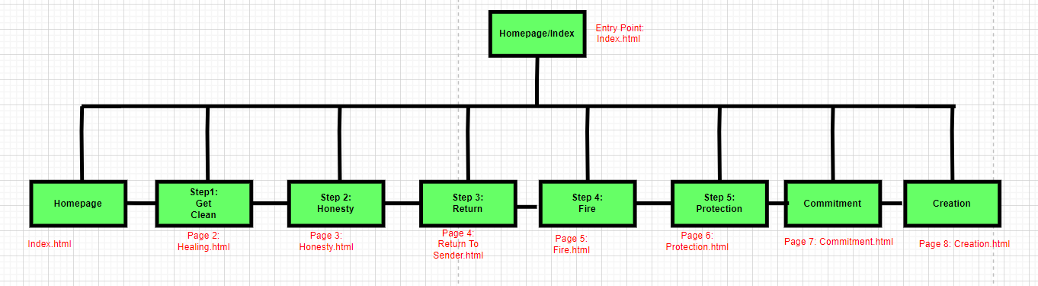

### Navigation Bar Below

I decided to place the navigation bar below the header image as it made it easier to find and press the buttons/page links for people with poor eyesight on smaller devices such as lower budget smartphones.

.

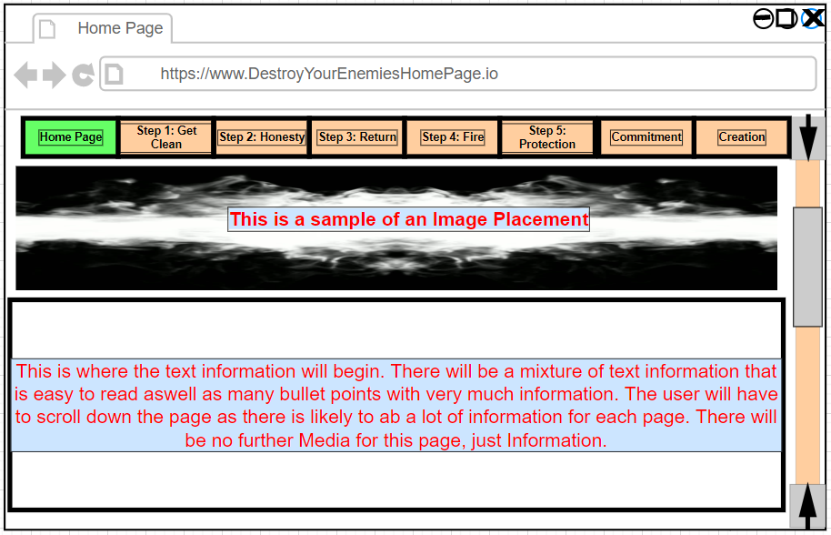

### Video embedding instead of essays.

Instead of having a page of text I embedded a youtube videos

### 

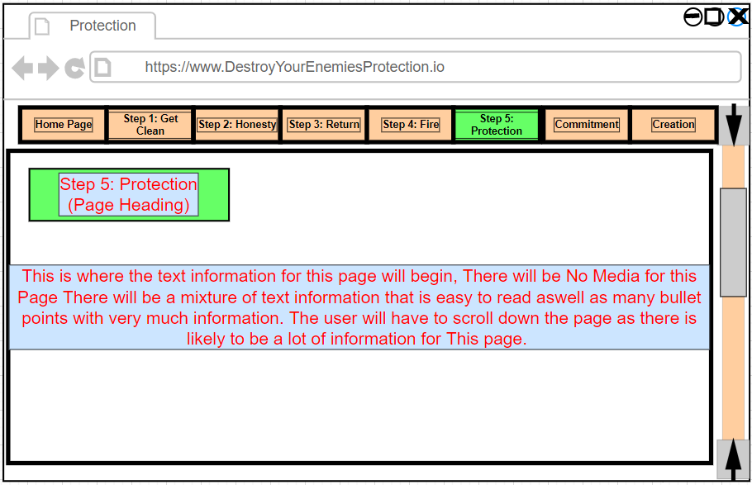

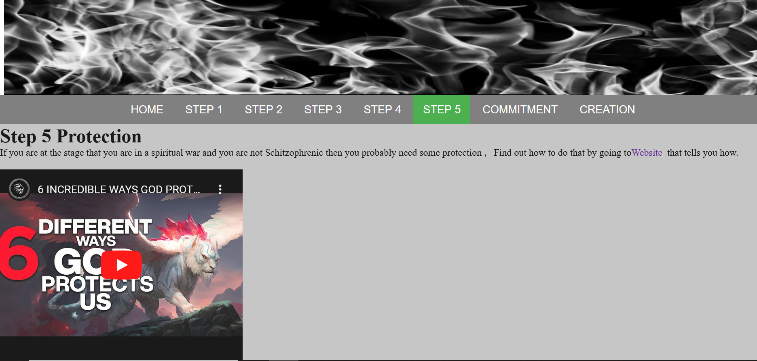

### Video embedding instead of essays

I imbedded a youtube video and put a brief description instead of a 6500 word essay .

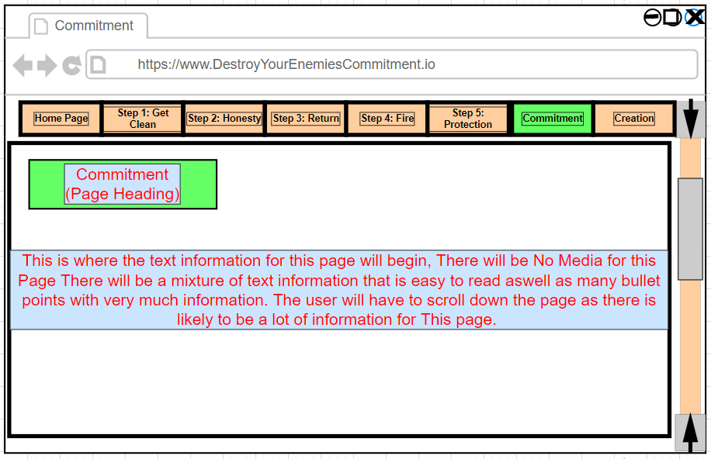

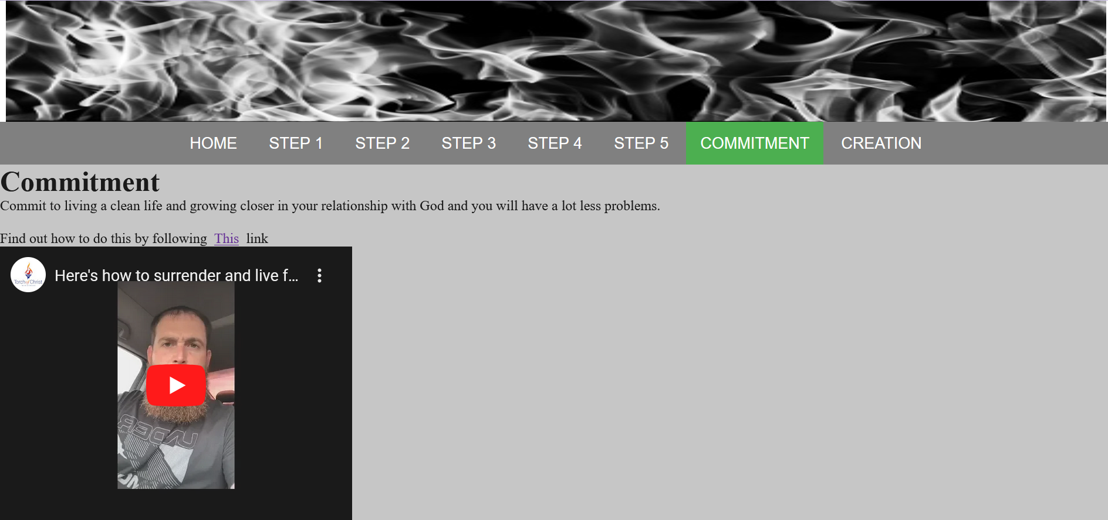

## 2. Changes proposed (that you could have done differently or could add to improve your website)

### Creation page

I could have put more effort into this page by adding text or audio file, which I didn’t do because I embedded extra videos instead on other pages.

### Future

I would go more into detail with detailed instructions rather than just hyperlinks to other websites, however this was created purely for this assignment, in reality if I was making a website for real I would probably just use a Wix template as it’s a lot easier and saves a lot of time.

### Smartphone enhancements

I would design the features and interactivity further around smartphone use, this time I didn’t as I simply ran out of time.

### Replace this title with a name for the change or addition y opose

I would create a local area page with links to the websites of local churches as well as google map locations highlighted for people requiring gps input.

# **Website development reflection**

## Three problems (difficulties) that you faced up during the website development phase? How did you overcome?

Time, Time, Time I noticed a limitation around time as well as a lack of ability to find comparative websites for inspiration, there are a lot of websites that are similar, however most of those have a lot of advertising as well as are very denominational specific which misses out on a lot of the important content, I did a lot of research and one problem is that really to create this properly so that the reader would actually understand takes approximately 200,000 words in total which people these days don’t want to read- they want to watch a movie about it instead so creating the website to match the original brief would make it very specific and more or less a worldwide one off and first however it would also take me 18 months to code in in such a way that it is readable with probably like 50 odd pages in total all linked together..

I intentionally tried to keep the website as simple as possible, however there was real limitations around what I could use graphic wise etc as this is supposed to be an information website that is text based and I didn’t want to drag the reader away from the informative text by adding lots of pictures and making it look like a social media application. My initial website was designed and the last assignment already submitted before Daniel announced in class that he didn’t want to see text based websites and that he wanted websites that are more interactive and look nice therefore I hyperlinked to other websites and embedded you tube videos to eliminate the boringness, however in the future I would make it more text based and probably just use a wix template to save months worth of development time.

All in all the end result is nothing like I had planned however it was simply a matter of time and putting out what I hope might score more than 51%

## What positives will you take away from this web development course

There are a lot of free and easy to use resources available to developers, making a website isn’t as hard as people think. The class exercises were a great confidence booster.

## What improvements could be made to this web development course

Probably more of a focus on real world designs and how to create a fully interactive website e.g.”Trademe.co.nz” We learned a lot of information around how to create very good but very basic websites, it would be nice to create a smaller version of trade me where there is a huge amount of user input as well as complexity.

## What was most helpful in this web development course

The weekly Lab sessions, As we were able to encounter difficulties in class Daniel was able to help us resolve those problems each week, we were then able to keep those completed exercises and use them as a template if needed or a code reference.

# References:

The screenshots that I have used for this report are my own art and do not require a reference, the youtube videos are embedded not stolen or copied therefore they are only a hyperlink and require.

Fire photo for the top of the website:

<https://media.istockphoto.com/photos/blazing-fire-flame-black-and-white-for-background-and-abstract-picture-id893107732?k=6&m=893107732&s=170667a&w=0&h=kyjuKdjWpJ0p4UhQ9S7z9QTUQJPLL7QeslL8T0ZdYA4=>

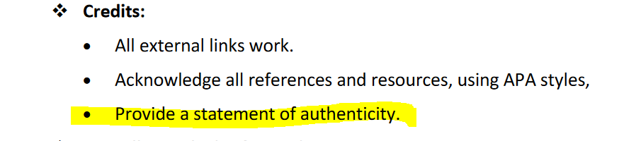

I Gregory Wilkins confirm that this is all of my own work as at 2:13Am 30/10/2022